**Experiment 1**

**Shashwat Tripathi  
D15A Batch C**

**Roll No: 64**

**AIM : To study a Web Analytics Tool**

**OUTPUT :**

**1. What is Web Analytics?**

Web analytics refers to the measurement, collection, analysis, and reporting of web data to understand and optimize web usage. It involves the examination of user behavior on a website to gain insights into various aspects such as the number of visitors, their interactions, the effectiveness of marketing campaigns, and overall website performance. Web analytics helps businesses and website owners make informed decisions to enhance the user experience, increase engagement, and achieve specific business goals.

**2. Web Analytics Tools and Their Features:**

There are several web analytics tools available, each with its features. Some prominent ones include:

a. Google Analytics:

- Features:

- Traffic and conversion tracking

- Audience demographics and interests

- Real-time reporting

- E-commerce tracking

- Customizable dashboards

b. Adobe Analytics:

- Features:

- Advanced segmentation

- Real-time analytics

- Cross-device tracking

- Predictive analytics

- Integration with Adobe Marketing Cloud

c. Hotjar:

- Features:

- Heatmaps to visualize user behavior

- Session recordings

- Conversion funnel analysis

- Feedback polls and surveys

d. Matomo (formerly Piwik):

- Features:

- Open-source analytics

- Customizable dashboards

- User privacy-focused

- Goal tracking

- E-commerce analytics

e. Crazy Egg:

- Features:

- Heatmaps and scrollmaps

- A/B testing

- User recordings

- Audience insights

- Conversion rate optimization tools

**3. Why is it Important to Learn Web Analytics?**

Learning web analytics is crucial for several reasons:

- Data-Driven Decision Making: Web analytics provides data-driven insights that help organizations make informed decisions to improve website performance and achieve business objectives.

- User Experience Optimization: Understanding user behavior allows for the optimization of the user experience, leading to increased satisfaction and engagement.

- Marketing Effectiveness: Web analytics helps measure the success of marketing campaigns, identify the most effective channels, and allocate resources appropriately.

- Business Growth: By analyzing data, organizations can identify growth opportunities, target specific audiences, and refine strategies to drive business growth.

**4. Key Performance Indicators (KPIs) for Your Website:**

The selection of KPIs depends on the specific goals and objectives of your website. Some common KPIs include:

- 1. Traffic Sources: Understanding where your website traffic is coming from (organic search, social media, referrals) helps optimize marketing efforts.

- 2. Conversion Rate: Tracking the percentage of visitors who complete a desired action (purchase, sign-up) indicates the effectiveness of your website in achieving goals.

- 3. Bounce Rate: The percentage of visitors who navigate away from the site after viewing only one page. A high bounce rate may indicate issues with content or user experience.

- 4. Average Session Duration: The average time visitors spend on your website can indicate engagement levels.

- 5. Pageviews:Tracking the number of pages viewed helps understand user engagement and content popularity.

Selecting KPIs aligned with your business objectives allows you to monitor and measure success, guiding strategic decisions to improve overall website performance.

Link to my website: <https://sollertia.vercel.app/>

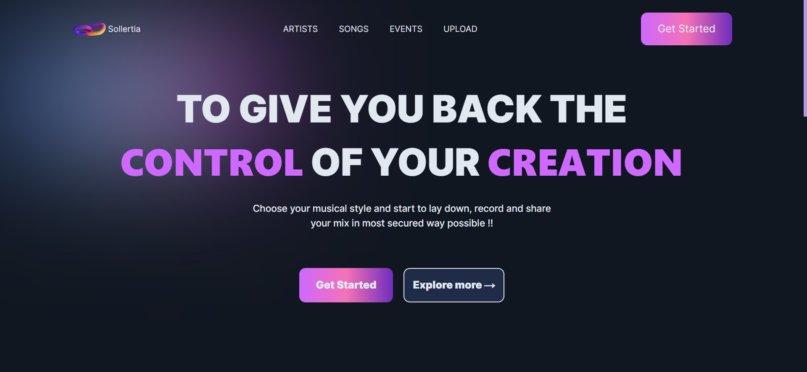

This is the landing page of Google Analytics, where it shows the basic analytics of my website like users, event counts (like scroll, click), conversion rate & new users.

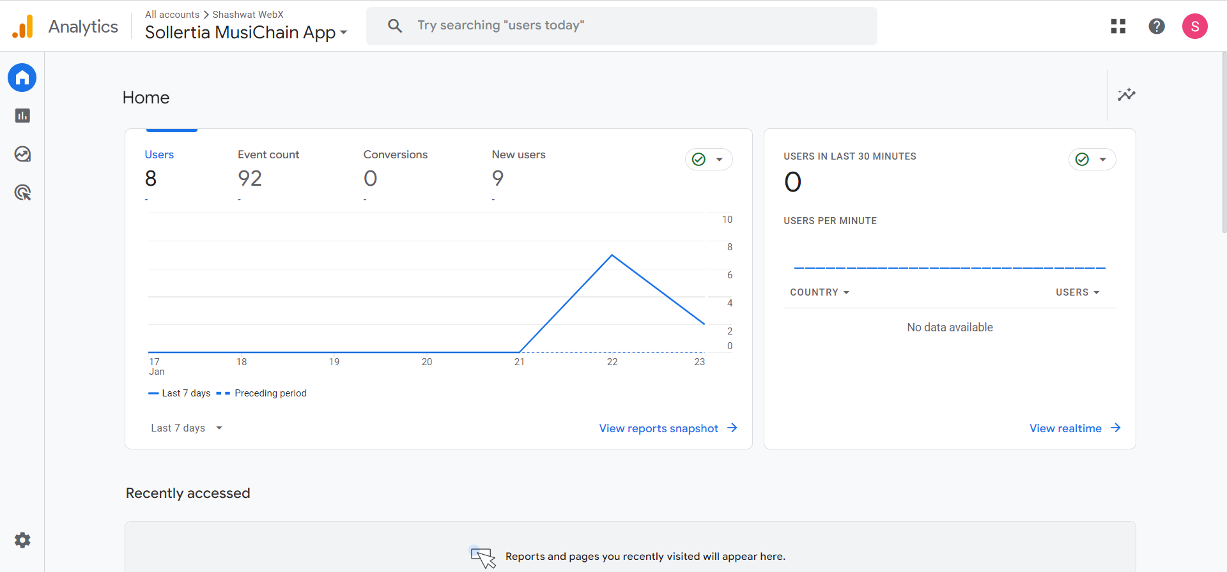



This gives the analysis of traffic on each page of website, since my website is a SPA(Single Page Application) it displays only one page “Sollertia”.

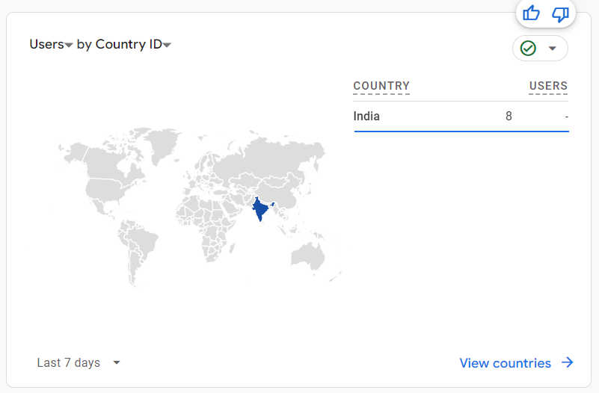

The above picture gives us demographic information from where our user base is. Currently, only my friends accessed my website so it shows all the users are from India.

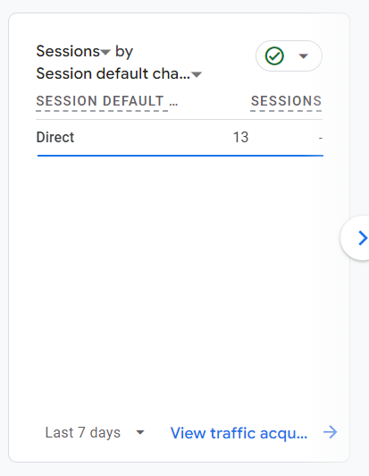

This shows how my website url is visited ‘direct’ if it is directly searched and visited ‘referal’ if it redirected through any third party website.

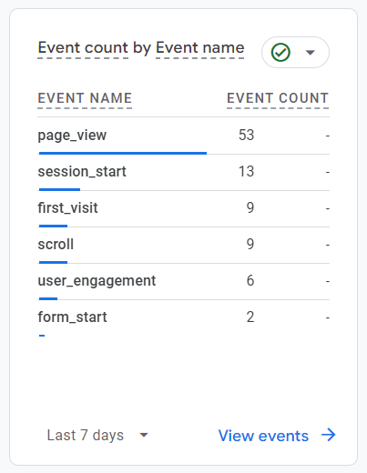

It shows what all events have been done by users on my website for example:53 people viewed the page.

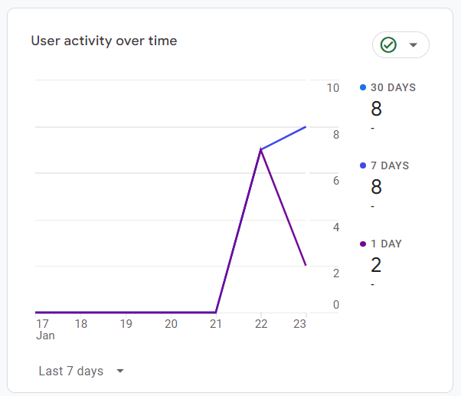

This shows the user activity over the past 7 days, this is from the time I added Google Analytics script in my website.

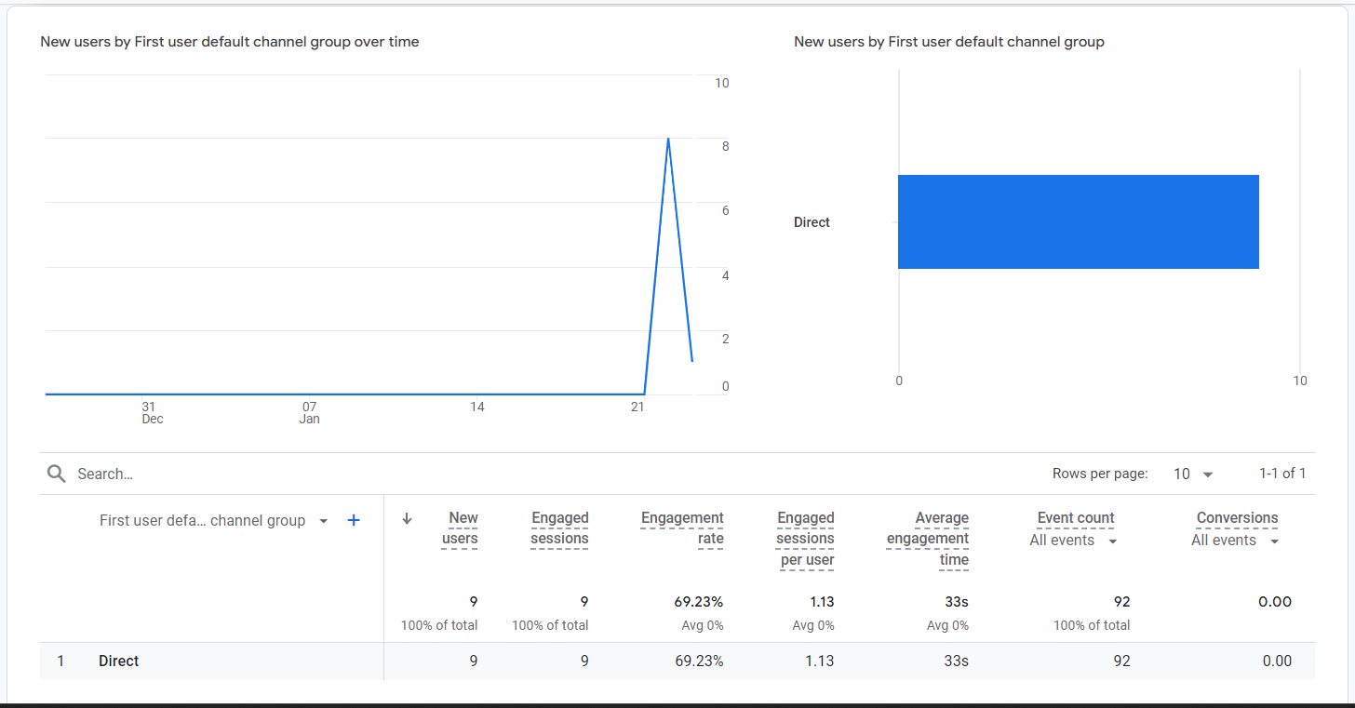

This shows the complete details about the engagement session, avg engagement time, event counts, etc.

**CONCLUSION : Thus, we have studied about Web analytics, understood its importance in performance of the website and also implemented Google analytics on our own deployed website.**